10.3.5 Render - Cycles Render Engine - Nodes
Introduction 2
Shaders 3
Textures 3
More 3
Open Shading Language 3
Open Shading Language 3
Script Node 4
Writing Shaders 4
Closures 4
BSDF 5
Hair 5
BSSRDF 5
Volume 5
Other 5
Attributes 6
Trace 7
Input Nodes 7
Camera Data 7
Value 7
RGB 7
Attribute 7
Wireframe 8
Geometry 8
Light Path 8
Object Info 9
Fresnel 9
Layer Weight 10
Texture Coordinate 10
UV Map 11
Particle Info 11
Hair Info 11
Tangent 12
Output Nodes 12
Material Output 12
Lamp Output 12
World Output 12
Shader Nodes 12
Diffuse 12
Translucent 13
Glossy 14
Anisotropic 14
Toon 15
Transparent 15
Glass 16
Principled Node 17
Inputs 18
Properties 19
Outputs 19
Examples 19
Refraction 22
Velvet 23
Subsurface Scattering 23
Emission 24
Background 25
Holdout 25
Ambient Occlusion 26
Mix and Add 26
Texture Nodes 27
Image Texture 27
Environment Texture 28
Sky Texture 29
Noise Texture 29
Wave Texture 30
Voronoi Texture 31
Musgrave Texture 31
Gradient Texture 32
Magic Texture 33
Checker Texture 33
Brick Texture 34
Options 34
Sockets 34
Point Density 35
Options 35
Sockets 36
More Nodes 36
Value 36
RGB 36
Geometry 36
Wireframe 37
Wavelength 37
Blackbody 37
Texture Coordinates 37
Bump 38
Vector Transform 38
Tangent 38
Normal Map 38
Object Info 39
Particle Info 39
Hair Info 40
Attribute 40
Mapping 40
Layer Weight 40
Fresnel 41
Light Path 41
Light Falloff 42
Nodes shared with the Compositor 42

Introduction

Materials, lights and backgrounds are all defined using a network of shading nodes. These nodes output values, vectors, colors and shaders.

Shaders
An important concept to understand when building node setups is that of the shader socket. The output of all surface and volume shaders is a shader, describing lighting interaction at the surface or of the volume, rather than the color of the surface.
There are a few types of shaders available as nodes:
- BSDF shader describing light reflection, refraction and absorption at an object surface.
- Emission shader describing light emission at an object surface or in a volume.
- Volume shader describing light scattering inside a volume.
- Background shader describing light emission from the environment.
Each shader node has a color input, and outputs a shader. These can then be mixed and added together using Mix and Add Shader nodes. No other operations are permitted. The resulting output can then be used by the render engine to compute all light interactions, for direct lighting or global illumination.

Textures
Each texture type in Cycles corresponds to a node, with a texture coordinate and various parameters as input, and a color or value as output. No texture data-blocks are needed; instead node groups can be used for reusing texture setups.
For UV mapping and texture painting in the viewport, the Image texture node must be used. When setting such a node as active, it will be drawn in Textured draw mode, and can be painted on in texture paint mode.
The default texture coordinates for all nodes are Generated coordinates, with the exception of Image textures that use UV coordinates by default. Each node includes some options to modify the texture mapping and resulting color, and these can be edited in the texture properties.

More
Nodes for geometric data, texture coordinates, layering shaders and non-physically based tricks.

Open Shading Language
Custom nodes can be written using the Open Shading Language.

Open Shading Language

Users can now create their own nodes using Open Shading Language (OSL). Note that these nodes will only work for CPU rendering; there is no support for running OSL code on the GPU.
To enable it, select Open Shading Language as the shading system in the render settings.
Note
On Linux, C/C++ compiler tools (in particular /usr/bin/cpp) must be installed to compile OSL scripts.

Script Node
OSL was designed for node-based shading, and each OSL shader corresponds to a node in a node setup. To add an OSL shader, add a script node and link it to a text data-block or an external file. Input and output sockets will be created from the shader parameters on clicking the update button in the node or the text editor.
OSL shaders can be linked to the node in a few different ways. With the Internal mode, a text data-block is used to store the OSL shader, and the OSO bytecode is stored in the node itself. This is useful for distributing a .blend file with everything packed into it.
The External mode can be used to specify a .osl file on disk, and this will then be automatically compiled into a .oso file in the same directory. It is also possible to specify a path to a .oso file, which will then be used directly, with compilation done manually by the user. The third option is to specify just the module name, which will be looked up in the shader search path.
The shader search path is located in the same place as the scripts or configuration path, under:
Linux
$HOME/.config/Bforartists/2.76/shaders/
MS-Windows
C:\Users\$user\AppData\Roaming\Bforartists Foundation\Bforartists\2.76\shaders\
Mac OSX
/Users/$USER/Library/Application Support/Bforartists/2.76/shaders/
For use in production, we suggest to use a node group to wrap shader script nodes, and link that into other .blend files. This makes it easier to make changes to the node afterwards as sockets are added or removed, without having to update the script nodes in all files.

Writing Shaders
For more details on how to write shaders, see the OSL specification. Here is a simple example:
shader simple_material(
color Diffuse_Color = color(0.6, 0.8, 0.6),
float Noise_Factor = 0.5,
output closure color BSDF = diffuse(N))
{
color material_color = Diffuse_Color * mix(1.0, noise(P * 10.0), Noise_Factor);
BSDF = material_color * diffuse(N);
}

Closures
OSL is different from, for example, RSL or GLSL, in that it does not have a light loop. There is no access to lights in the scene, and the material must be built from closures that are implemented in the render engine itself. This is more limited, but also makes it possible for the render engine to do optimizations and ensure all shaders can be importance sampled.
The available closures in Cycles correspond to the shader nodes and their sockets; for more details on what they do and the meaning of the parameters, see the shader nodes manual.

BSDF
- diffuse(N)
- oren_nayar(N, roughness)
- diffuse_ramp(N, colors[8])
- phong_ramp(N, exponent, colors[8])
- diffuse_toon(N, size, smooth)
- glossy_toon(N, size, smooth)
- translucent(N)
- reflection(N)
- refraction(N, ior)
- transparent()
- microfacet_ggx(N, roughness)
- microfacet_ggx_aniso(N, T, ax, ay)
- microfacet_ggx_refraction(N, roughness, ior)
- microfacet_beckmann(N, roughness)
- microfacet_beckmann_aniso(N, T, ax, ay)
- microfacet_beckmann_refraction(N, roughness, ior)
- ashikhmin_shirley(N, T, ax, ay)
- ashikhmin_velvet(N, roughness)

Hair
- hair_reflection(N, roughnessu, roughnessv, T, offset)
- hair_transmission(N, roughnessu, roughnessv, T, offset)

BSSRDF
- bssrdf_cubic(N, radius, texture_blur, sharpness)
- bssrdf_gaussian(N, radius, texture_blur)

Volume
- henyey_greenstein(g)
- absorption()

Other
- emission()
- ambient_occlusion()
- holdout()
- background()

Attributes
Some object, particle and mesh attributes are available to the built-in getattribute() function. UV maps and vertex colors can be retrieved using their name. Other attributes are listed below:
geom:generated
Generated texture coordinates
geom:uv
Default render UV map
geom:dupli_generated
For instances, generated coordinate from duplicator object
geom:dupli_uv
For instances, UV coordinate from duplicator object
geom:trianglevertices
3 vertex coordinates of the triangle
geom:numpolyvertices
Number of vertices in the polygon (always returns 3 currently)
geom:polyvertices
Vertex coordinates array of the polygon (always 3 vertices currently)
geom:name
Name of the object
geom:is_curve
Is object a strand or not
geom:curve_intercept
Point along the strand, from root to tip
geom:curve_thickness
Thickness of the strand
geom:curve_tangent_normal
Tangent Normal of the strand
path:ray_length
Ray distance since last hit
object:location
Object location
object:index
Object index number
object:random
Per object random number generated from object index and name
material:index
Material index number
particle:index
Particle instance number
particle:age
Particle age in frames
particle:lifetime
Total lifespan of particle in frames
particle:location
Location of the particle
particle:size
Size of the particle
particle:velocity
Velocity of the particle
particle:angular_velocity
Angular velocity of the particle

Trace
We support the trace(point pos, vector dir, ...) function, to trace rays from the OSL shader. The “shade” parameter is not supported currently, but attributes can be retrieved from the object that was hit using the getmessage("trace", ..) function. See the OSL specification for details on how to use this.
This function can’t be used instead of lighting; the main purpose is to allow shaders to “probe” nearby geometry, for example to apply a projected texture that can be blocked by geometry, apply more “wear” to exposed geometry, or make other ambient occlusion-like effects.

Input Nodes

Camera Data
View Vector
A Camera space vector from the camera to the shading point.
View Z Depth
TODO
View Distance
Distance from the camera to the shading point.

Value
Input a scalar value.
Value
Value output.

RGB
Input an RGB color.
Color
RGB color output.

Attribute
Retrieve attribute attached to the object or mesh. Currently UV maps and vertex color layers can be retrieved this way by their names, with layers and attributes planned to be added. Also internal attributes like P (position), N (normal), Ng (geometric normal) may be accessed this way, although there are more convenient nodes for this.
Name
Name of the attribute.
Color output
RGB color interpolated from the attribute.
Vector output
XYZ vector interpolated from the attribute.
Fac output
Scalar value interpolated from the attribute.

Wireframe
Retrieve the edges of an object as it appears to cycles. As meshes are triangulated before being processed by cycles, topology will always appear triangulated when viewed with the Wireframe node.
Pixel Size
When enabled, set the size of edge lines in screen space.
Size
Thickness of edge lines.
Fac output
Black and white mask showing white lines representing edges according to the object’s topology.

Geometry
Geometric information about the current shading point. All vector coordinates are in World Space. For volume shaders, only the position and incoming vector are available.
Position
Position of the shading point.
Normal
Shading normal at the surface (includes smooth normals and bump mapping).
Tangent
Tangent at the surface.
True Normal
Geometry or flat normal of the surface.
Incoming
Vector pointing towards the point the shading point is being viewed from.
Parametric
Parametric coordinates of the shading point on the surface.
Backfacing
1.0 if the face is being viewed from the back side, 0.0 for the front side.
Pointiness
An approximation of the curvature of the mesh per-vertex. Lighter values indicate convex angles, darker values indicate concave angles.

Light Path
Node to find out for which kind of incoming ray the shader is being executed; particularly useful for non-physically based tricks. More information about the meaning of each type is in the Light Paths documentation.
Is Camera Ray output
1.0 if shading is executed for a camera ray, 0.0 otherwise.
Is Shadow Ray output
1.0 if shading is executed for a shadow ray, 0.0 otherwise.
Is Diffuse Ray output
1.0 if shading is executed for a diffuse ray, 0.0 otherwise.
Is Glossy Ray output
1.0 if shading is executed for a glossy ray, 0.0 otherwise.
Is Singular Ray output
1.0 if shading is executed for a singular ray, 0.0 otherwise.
Is Reflection Ray output
1.0 if shading is executed for a reflection ray, 0.0 otherwise.
Is Transmission Ray output
1.0 if shading is executed for a transmission ray, 0.0 otherwise.
Ray Length output
Distance traveled by the light ray from the last bounce or camera.
Ray Depth
Number of times the ray has “bounced”, i.e. been reflected or transmitted on interaction with a surface.
Note
Passing through a transparent shader does not count as a normal “bounce”.

Transparent Depth
Number of times the ray has passed through a transparent shader.

Object Info
Information about the object instance. This can be useful to give some variation to a single material assigned to multiple instances, either manually controlled through the object index, based on the object location, or randomized for each instance. For example a Noise texture can give random colors or a Color ramp can give a range of colors to be randomly picked from.
Location
Location of the object in world space.
Object Index
Object pass index, same as in the Object Index pass.transformed.
Material Index
Material pass index, same as in the Material Index pass.
Random
Random number unique to a single object instance.

Fresnel
Dielectric fresnel, computing how much light is refracted through and how much is reflected off a layer. The resulting weight can be used for layering shaders with the Mix Shader node. It is dependent on the angle between the surface normal and the viewing direction.
IOR input
Index of refraction of the material being entered.
Fresnel output
Fresnel weight, indicating the probability with which light will reflect off the layer rather than passing through.

Layer Weight
Output weights typically used for layering shaders with the Mix Shader node.
Blend input
Blend between the first and second shader.
Fresnel output
Dielectric fresnel weight, useful for example for layering diffuse and glossy shaders to create a plastic material. This is like the Fresnel node, except that the input of this node is in the often more-convenient 0.0 to 1.0 range.
Facing output
Weight that blends from the first to the second shader as the surface goes from facing the viewer to viewing it at a grazing angle.

Texture Coordinate
Commonly used texture coordinates, typically used as inputs for the Vector input for texture nodes.
Generated output
Automatically-generated texture coordinates from the vertex positions of the mesh without deformation, keeping them sticking to the surface under animation. Range from 0.0 to 1. 0 over the bounding box of the undeformed mesh.
Normal output
Object space normal, for texturing objects with the texture staying fixed on the object as it transformed.
UV output
UV texture coordinates from the active render UV map.
Object output
Position coordinate in object space.
Camera output
Position coordinate in camera space.
Window output
Location of shading point on the screen, ranging from 0.0 to 1. 0 from the left to right side and bottom to top of the render.
Reflection output
Vector in the direction of a sharp reflection, typically used for environment maps.
Object
Specific object to use for object space coordinates. This only affects the Object output.
From Dupli
If the material is applied to a dupli object, use texture coordinates from the parent object. This only affects the Generated and UV outputs.

From left to right: Sphere with UV mapped texture. Small spheres duplicated to the faces of the textured sphere using duplifaces. Small spheres with From Dupli enabled, using the UV map of the large sphere.
Note
From Dupli only works with the UV output when the dupli object is instanced from faces, either with particles or duplifaces.

UV Map
Retrieve specific UV maps. Unlike the Texture Coordinate node which only provides the active UV map, this node can retrieve any UV map belonging to the object using the material.
From Dupli
See the From Dupli option of the Texture Coordinate node.
UV Map
UV map to use.
UV output
UV mapping coordinates from the specified UV layer.

Particle Info
For objects instanced from a particle system, this node give access to the data of the particle that spawned the instance.
Index
Index number of the particle (from 0 to number of particles).
Age
Age of the particle in frames.
Lifetime
Total lifespan of the particle in frames.
Location
Location of the particle.
Size
Size of the particle.
Velocity
Velocity of the particle.
Angular Velocity
Angular velocity of the particle.

Hair Info
This node gives access to strand information.
Is strand
Returns 1 when the shader is acting on a strand, otherwise 0.
Intercept
The point along the strand where the ray hits the strand (1 at the tip and 0 at the root).
Thickness
The thickness of the strand at the point where the ray hits the strand.
Tangent Normal
Tangent normal of the strand.

Tangent
Generates a tangent direction for the Anisotropic BSDF.
Direction Type
The tangent direction can be derived from a cylindrical projection around the X, Y or Z axis (Radial), or from a manually created UV Map for full control.
Tangent Output
The tangent direction vector.

Output Nodes

Output nodes are the final node in every node tree. Although you can add more than one, only one will be used (indicated by a colored or darkened header). Output nodes are always preceded by Shaders except in the case of the Displacement of a Material Output.

Material Output
Surface
The surface output of the material
Volume
Currently under independent development, does nothing
Displacement
Used to create bump mapping or actual subdivided Displacement

Lamp Output
Surface
Not an actual surface, but the final output of a Lamp Object

World Output
Surface
The appearance of the environment, usually preceded by a Background shader
Volume
Currently under independent development, does nothing

Shader Nodes

Diffuse
Lambertian and Oren-Nayar diffuse reflection.
Color input
Color of the surface, or physically speaking, the probability that light is reflected or transmitted for each wavelength.
Roughness input
Surface roughness; 0.0 gives standard Lambertian reflection, higher values activate the Oren-Nayar BSDF.
Normal input
Normal used for shading; if nothing is connected the default shading normal is used.
BSDF output
Diffuse BSDF shader.
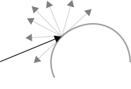
Diffuse behavior
 | 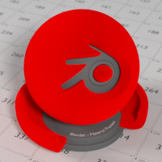

Translucent
Lambertian diffuse transmission.
Color input
Color of the surface, or physically speaking, the probability that light is transmitted for each wavelength.
Normal input
Normal used for shading; if nothing is connected the default shading normal is used.
BSDF output
Translucent BSDF shader.
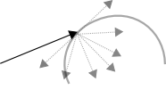

Translucent Shader

Glossy
Glossy reflection with microfacet distribution, used for materials such as metal or mirrors.
Distribution
Microfacet distribution to use. Sharp results in perfectly sharp reflections like a mirror, while Beckmann, GGX and Ashikhmin-Shirley can use the Roughness input for blurry reflections.
Color input
Color of the surface, or physically speaking, the probability that light is reflected for each wavelength.
Roughness input
Influences sharpness of the reflection; perfectly sharp at 0.0 and smoother with higher values.
Normal input
Normal used for shading; if nothing is connected the default shading normal is used.
BSDF output
Glossy BSDF shader.
Sharp Glossy | Rough Glossy
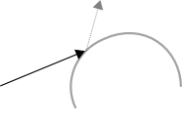 | 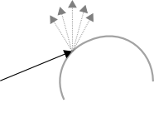
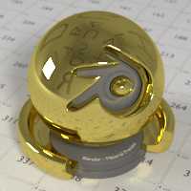 | 

Anisotropic
Anisotropic glossy reflection, with separate control over U and V direction roughness. The tangents used for shading are derived from the active UV map. If no UV map is available, they are automatically generated using a sphere mapping based on the mesh bounding box.
Distribution
Microfacet distribution to use. Sharp results in perfectly sharp reflections like a mirror, while Beckmann, GGX and Ashikhmin-Shirley can use the Roughness input for blurry reflections.
Color input
Color of the surface, or physically speaking, the probability that light is reflected for each wavelength.
Roughness input
Sharpness of the reflection; perfectly sharp at 0.0 and smoother with higher values.
Anisotropy input
Amount of anisotropy in the reflection; 0.0 gives a round highlight. Higher values give elongated highlights orthogonal to the tangent direction; negative values give highlights shaped along the tangent direction.
Rotation input
Rotation of the anisotropic tangent direction. Value 0.0 equals 0- rotation, 0.25 equals 90- and 1.0 equals 360- = 0- . This can be used to texture the tangent direction.
Normal input
Normal used for shading; if nothing is connected the default shading normal is used.
Tangent input
Tangent used for shading; if nothing is connected the default shading tangent is used.
BSDF output
Anisotropic glossy BSDF shader.
  Anisotropic rotation on 0 |   Anisotropic rotation on 0.25 (90- )

Toon
Diffuse and Glossy Toon BSDF for creating cartoon light effects.
Color input
Color of the surface, or physically speaking, the probability that light is reflected for each wavelength.
Size input
Parameter between 0.0 and 1.0 that gives a angle of reflection between 0- and 90- .
Smooth input
This value specifies an angle over which a smooth transition from full to no reflection happens.
Normal input
Normal used for shading; if nothing is connected the default shading normal is used.
BSDF output
Toon BSDF shader.

Toon Shader

Transparent
Transparent BSDF without refraction, passing straight through the surface, as if there were no geometry there. Useful with alpha maps, for example. This shader affects light paths somewhat differently than other BSDF s. Note that only pure white transparent shaders are completely transparent.
Color input
Color of the surface, or physically speaking, the probability for each wavelength that light is blocked or passes straight through the surface.
BSDF output
Transparent BSDF shader.
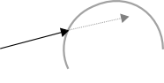
Transparent behaviour
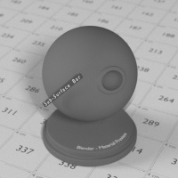  Transparent Shader (pure white) | 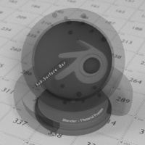  Transparent Shader (gray)

Glass
Glass-like shader mixing refraction and reflection at grazing angles. Like the transparent shader, only pure white will make it transparent. The glass shader tends to cause noise due to caustics. Since the Cycles path tracing integrator is not very good at rendering caustics, it helps to combine this with a transparent shader for shadows; for more details see here
Distribution
Microfacet distribution to use. Sharp results in perfectly sharp refractions like clear glass, while Beckmann and GGX can use the Roughness input for rough glass.
Color input
Color of the surface, or physically speaking, the probability that light is transmitted for each wavelength.
Roughness input
Influences sharpness of the refraction; perfectly sharp at 0.0 and smoother with higher values.
IOR input
Index of refraction defining how much the ray changes direction. At 1. 0 rays pass straight through like transparent; higher values give more refraction.
Normal input
Normal used for shading; if nothing is connected the default shading normal is used.
BSDF output
Glass BSDF shader.
Sharp Glass | Rough Glass
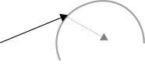 | 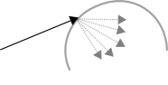
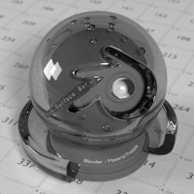 | 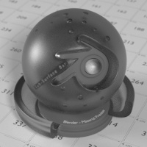

Principled Node
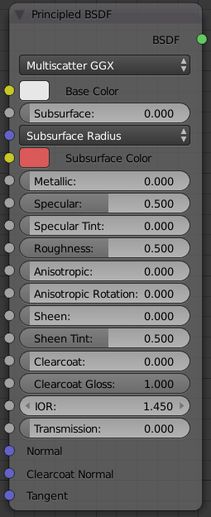
Principled Node.
The Principled BSDF that combines multiple layers into a single easy to use node. It is based on the Disney principled model also known as the “PBR” shader, making it compatible with other software such as Pixar’s Renderman® and Unreal Engine®. Image textures painted or baked from software like Substance Painter® may be directly linked to the corresponding parameters in this shader.
This “Uber” shader includes multiple layers to create a wide variety of materials. The base layer is a user controlled mix between diffuse, metal, subsurface scattering and transmission. On top of that there is a specular layer, sheen layer and clearcoat layer.
Note
The emphasis on compatibility with other software means that it interprets certain input parameters differently from older blender nodes.

Inputs
Base Color
Diffuse or metal surface color.
Subsurface
Mix between diffuse and subsurface scattering.
Subsurface Radius
Average scattering distance for RGB channels.
Subsurface Color
Subsurface scattering base color.
Metallic
Mix between dielectric (diffuse and specular with possible transparency) and metallic (fully specular with complex Fresnel).
Specular
Amount of dielectric specular reflection. Specifies facing (along normal) reflectivity in the most common 0 - 8% range.
Hint
To compute this value for a realistic material with a known index of refraction, you may use this special case of the Fresnel formula: specular=sqr((ior−1)/(ior+1))/0.08
For example:
- water: ior = 1.33, specular = 0.25
- glass: ior = 1.5, specular = 0.5
- diamond: ior = 2.417, specular = 2.15
Since materials with reflectivity above 8% do exist, the field allows values above 1.
Specular Tint
Tints the facing specular reflection using the base color, while glancing reflection remains white.
Normal dielectrics have colorless reflection, so this parameter is not technically physically correct and is provided for faking the appearance of materials with complex surface structure.
Roughness
Specifies microfacet roughness of the surface for diffuse and specular reflection.
Hint
When converting from the older Glossy BSDF node, use the square root of the original value.
Anisotropic
Amount of anisotropy for specular reflection.
Anisotropic Rotation
Rotates the direction of anisotropy, with 1.0 going full circle.
Hint
Compared to the Anisotropic BSDF node, the direction of highlight elongation is rotated by 90°. Add 0.25 to the value to correct.
Sheen
Amount of soft velvet like reflection near edges, for simulating materials such as cloth.
Sheen Tint
Mix between white and using base color for sheen reflection.
Clearcoat
Extra white specular layer on top of others. This is useful for materials like car paint and the like.
Clearcoat Roughness:
Roughness of clear coat specular.
IOR
Index of refraction for transmission.
Transmission
Mix between fully opaque surface at zero and fully glass like transmission at one.
Transmission Roughness
With GGX distribution controls roughness used for transmitted light.
Normal
Controls the normals of the base layers
Clearcoat Normal
Controls the normals of the Clearcoat layer.
Tangent
Controls the tangent for the Anisotropic layer.

Properties
Distribution
Microfacet distribution to use.
GGX
A method that is faster than Multiple-scattering GGX but is less physically accurate. Selecting it enables the Transmission Roughness input.
Multiple-scattering GGX
Takes multiple bounce (scattering) events between microfacets into account. This gives a more energy conserving results, which would otherwise be visible as excessive darkening.

Outputs
BSDF
Standard shader output.

Examples
Below are some examples of how all the Principled Node’s parameters interact with each other.
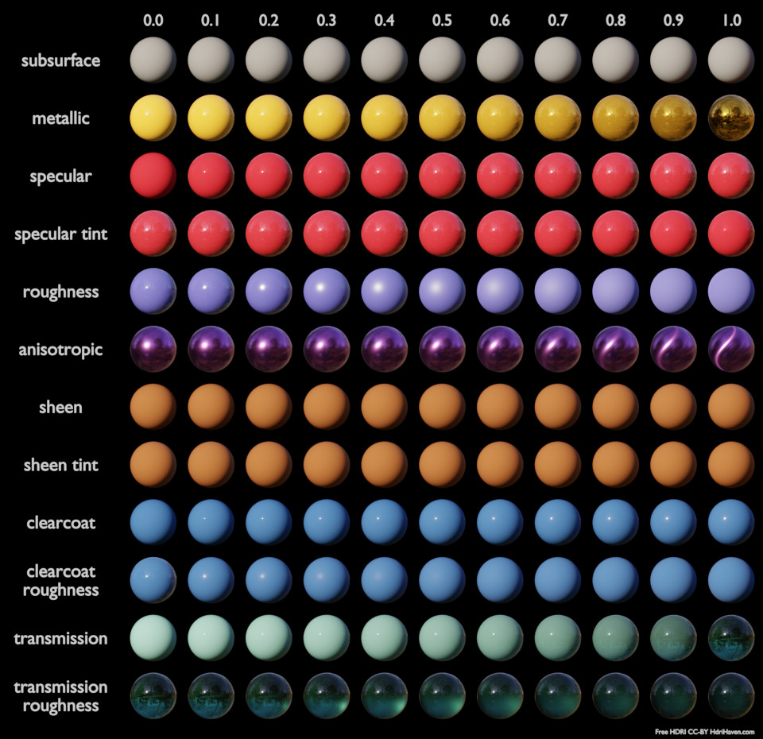
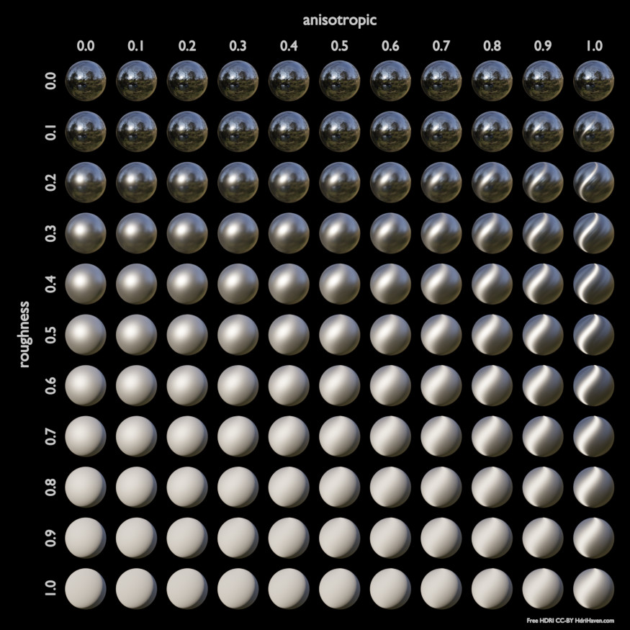
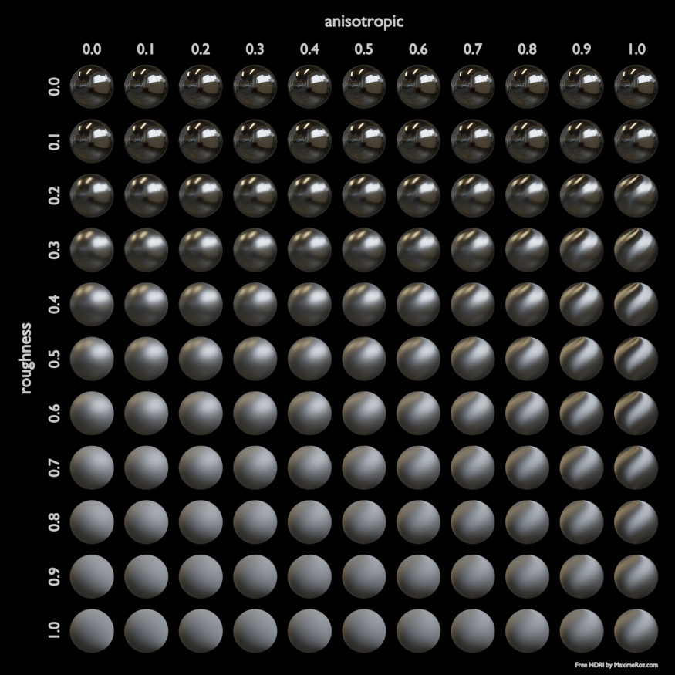

Refraction
Glossy refraction with sharp or microfacet distribution, used for materials that transmit light. For best results this node should be considered as a building block and not be used on its own, but rather mixed with a glossy node using a fresnel factor. Otherwise it will give quite dark results at the edges for glossy refraction.
Distribution
Microfacet distribution to use. Sharp results in perfectly sharp refractions, while Beckmann and GGX can use the Roughness input for blurry refractions.
Color input
Color of the surface, or physically speaking, the probability that light is refracted for each wavelength.
Roughness input
Influences sharpness of the refraction; perfectly sharp at 0.0 and smoother with higher values.
Normal input
Normal used for shading; if nothing is connected the default shading normal is used.
BSDF output
Glossy BSDF shader.

Refraction Shader.

Velvet
Velvet reflection shader for materials such as cloth. It is meant to be used together with other shaders (such as a Diffuse Shader) and isn’t particularly useful on it’s own.
Color input
Color of the surface, or physically speaking, the probability that light is reflected for each wavelength.
Sigma input
Variance of the normal distribution, controlling the sharpness of the peak - can be thought of as a kind of roughness.
Normal input
Normal used for shading; if nothing is connected the default shading normal is used.
BSDF output
Velvet BSDF shader.
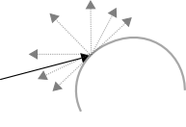
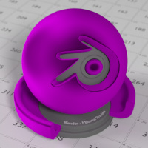
The Velvet Shader

Subsurface Scattering
Simple subsurface multiple scattering, for materials such as skin, wax, marble, milk and others. For these materials, rather than light being reflect directly off the surface, it will penetrate the surface and bounce around internally before getting absorbed or leaving the surface at a nearby point.
How far the color scatters on average can be configured per RGB color channel. For example, for skin, red colors scatter further, which gives distinctive red-colored shadows, and a soft appearance.
Falloff
Lighting distance falloff function. Cubic is a sharp falloff useful for many simple materials. The function is (radius - x) 3 Gaussian gives a smoother falloff following a normal distribution, which is particularly useful for more advanced materials that use measured data that was fitted to one or more such Gaussian functions. The function is e -8x2/radius2, such that the radius roughly matches the maximum falloff distance. To match a given measured variance v, set radius = sqrt(16*v).
Color input
Color of the surface, or physically speaking, the probability that light is reflected for each wavelength.
Scale input
Global scale factor for the scattering radius.
Radius input
Scattering radius for each RGB color channel, the maximum distance that light can scatter.
Sharpness input
Used only with Cubic falloff. Values increasing from 0 to 1 prevents softening of sharp edges and reduces unwanted darkening.
Normal input
Normal used for shading; if nothing is connected the default shading normal is used.
Texture Blur input
How much of the texture will be blurred along with the lighting, mixing the texture at the incoming and outgoing points on the surface. Note that the right choice depends on the texture. Consider for example a texture created from a photograph of skin, in this cases the colors will already be pre-blurred and texture blur could be set to 0. Even for hand painted textures no or minimal blurring might be appropriate, as a texture artist would likely paint in softening already, one would usually not even know what an unblurred skin texture looks like, we always see it blurred. For a procedural texture on the other hand this option would likely have a higher value.
BSSRDF output
BSSRDF shader.

A skin-toned SSS shader with color radius: 1.0, 0.8, 0.5.

Emission
Lambertian emission, to be used for material and lamp surface outputs.
Color input
Color of the emitted light.
Strength input
Strength of the emitted light. For point and area lamps, the unit is Watts. For materials, a value of 1.0 will ensure that the object in the image has the exact same color as the Color input, i.e. make it ‘shadeless’.
Emission output
Emission shader.
  Emission shader, with strength at 1.0 |   Emission shader, with strength at 3.0
Cycles uses a physically correct light falloff by default, whereas Bforartists Internal uses a smoothed falloff with a Distance parameter. A similar effect can be found by using the Light Falloff node with the Smooth parameter.
Lamp strength for point, spot and area lamps is specified in Watts. This means you typically need higher values than Bforartists Internal, as you couldn’t use a 1W lamp to light a room; you need something stronger like a 100W lamp.
Sun lamps are specified in Watts/m^2, which require much smaller values like 1 W/m^2. This can be confusing, but specifying strength in Watts wouldn’t have been convenient; the real sun for example has strength 384600000000000000000000000W. Emission shaders on meshes are also in Watts/m^2.

Background
Background light emission. This node should only be used for the world surface output; it is ignored in other cases.
Color input
Color of the emitted light.
Strength input
Strength of the emitted light.
Background output
Background shader.

Holdout
The holdout shader creates a “hole” in the image with zero alpha transparency, which is useful for compositing (see alpha channel).
Note that the holdout shader can only create alpha when Properties ‣ Render ‣ Film ‣ Transparent is enabled. If it’s disabled, the holdout shader will be black.
Holdout output
Holdout shader.
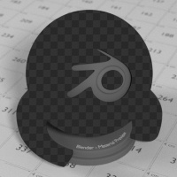
The checkered area is a region with zero alpha.

Ambient Occlusion
The ambient occlusion node gives per-material control for the amount of AO. When AO is enabled in the world, it affects all diffuse BSDFs in the scene. With this option it’s possible to let only some materials be affected by AO, or to let it influence some materials more or less than others.
Color input
surface reflection color.
AO output
Ambient Occlusion shader.

White AO shader.

Mix and Add
Mix or add shaders together. Mixing can be used for material layering, where the Fac input may, for example, be connected to a Blend Weight node.
Shader inputs
Shaders to mix, such that incoming rays hit either with the specified probability in the Fac socket.
Fac input
Blend weight to use for mixing two shaders; at zero it uses the first shader entirely and at one the second shader.
Shader output
Mixed shader.

A mix of a glossy and a diffuse shader makes a nice ceramic material.

Texture Nodes

Image Texture
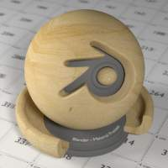
Image texture from GoodTextures.com
Use an image file as a texture.
Image Data-Block
Image data-block used as the image source. Currently not all images supported by Bforartists can be used by Cycles. In particular, generated, packed images or animations are not supported currently.
Projection
Projection to use for mapping the textures.
- Flat will use the XY coordinates for mapping.
- Box will map the image to the 6 sides of a virtual box, based on the normal, using XY, YZ and XYZ coordinates depending on the side.
- Sphere will map the image to the sphere using Z axis as central.
- Tube will map the tube to the sphere using Z axis as central.
Projection Blend
For Box mapping, the amount to blend between sides of the box, to get rid of sharp transitions between the different sides. Blending is useful to map a procedural-like image texture pattern seamlessly on a model. 0.0 gives no blending; higher values give a smoother transition.
Color Space
Type of data that the image contains, either Color or Non-Color Data. For most color textures the default of Color should be used, but in case of e.g. a bump or alpha map, the pixel values should be interpreted as Non-Color Data, to avoid doing any unwanted color space conversions.
Extension Type
Extension type defines how the image is extrapolated past the original bounds:
- Repeat will repeat the image horizontally and vertically giving tiled-looking result.
- Extend will extend the image by repeating pixels on it’s edges.
- Clip will set all the extended pixels values to transparent black.
Vector input
Texture coordinate for texture lookup. If this socket is left unconnected, UV coordinates from the active UV render layer are used.
Color output
RGB color from image. If the image has alpha, the color is premultiplied with alpha if the Alpha output is used, and unpremultiplied or straight if the Alpha output is not used.
Alpha output
Alpha channel from image.

Environment Texture

HDR image from OpenFootage.net
Use an environment map image file as a texture. The environment map is expected to be in Latitude/Longitude or ‘latlong’ format.
Image Data-Block
Image data-block used as the image source. Currently not all images supported by Bforartists can be used by Cycles. In particular, generated, packed images or animations are not supported currently.
Color Space
Type of data that the image contains, either Color or Non-Color Data. For most color textures the default of Color should be used, but in case of e.g. a bump or alpha map, the pixel values should be interpreted as Non-Color Data, to avoid doing any unwanted color space conversions.
Vector input
Texture coordinate for texture lookup. If this socket is left unconnected, the image is mapped as environment with the Z axis as up.
Color output
RGB color from the image. If the image has alpha, the color is premultiplied with alpha if the Alpha output is used, and unpremultiplied if the Alpha output is not used.
Alpha output
Alpha channel from image.

Sky Texture

Sky Texture
Procedural Sky texture.
Sky Type
Sky model to use (Preetham or Hosek / Wilkie).
Sun Direction
Sun direction vector.
Turbidity
Atmospheric turbidity. (2: Arctic like, 3: clear sky, 6: warm/moist day, 10: hazy day)
Ground Albedo
Amount of light reflected from the planet surface back into the atmosphere. (RGB 0,0,0 is black, 1,1,1 is white).
Vector
Texture coordinate to sample texture at; defaults to Generated texture coordinates if the socket is left unconnected.
Color output
Texture color output.

Noise Texture

Noise Texture with high detail
Procedural Perlin noise texture, similar to the Clouds texture in Bforartists Internal.
Vector input
Texture coordinate to sample texture at; defaults to Generated texture coordinates if the socket is left unconnected.
Scale input
Overall texture scale.
Detail input
Amount of noise detail.
Distortion input
Amount of distortion.
Color output
Texture color output.
Fac output
Texture intensity output.

Wave Texture

Default wave texture
Procedural bands or rings texture with noise distortion.
Type
Bands or Rings shaped waves.
Vector input
Texture coordinate to sample texture at; defaults to Generated texture coordinates if the socket is left unconnected.
Scale input
Overall texture scale.
Distortion input
Amount of distortion of the wave (similar to the Marble texture in Bforartists Internal).
Detail input
Amount of distortion noise detail.
Detail Scale input
Scale of distortion noise.
Color output
Texture color output.
Fac output
Texture intensity output.

Voronoi Texture
  Voronoi texture, type: Intensity |   Voronoi texture, type: Cells
Procedural texture producing Voronoi cells.
Type
Intensity or Cells output.
Vector input
Texture coordinate to sample texture at; defaults to Generated texture coordinates if the socket is left unconnected.
Scale input
Overall texture scale.
Color output
Texture color output.
Fac output
Texture intensity output.

Musgrave Texture
Advanced procedural noise texture. Note that it often needs some adjustments (multiplication and addition) in order to see more detail.
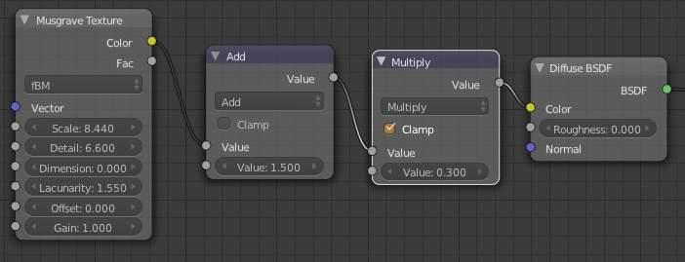  Nodes for the image to the right |   Remapped Musgrave texture such that most values are visible
Type
Multifractal, Ridged Multifractal, Hybrid Multifractal, fBM, Hetero Terrain.
Vector input
Texture coordinate to sample texture at; defaults to Generated texture coordinates if the socket is left unconnected.
Scale input
Overall texture scale.
Detail input
Amount of noise detail.
Dimension input
The highest fractal dimension, specified as the highest scale for the steps of the intensity.
Lacunarity input
The space of the lacunarity, specified as a frequency factor.
Offset input
The offset of the fractal, specified between black and white values (Intensity)
Gain input
A multiplier for the gain input
Color output
Texture color output.
Fac output
Texture intensity output.

Gradient Texture

Gradient texture using object coordinates
A gradient texture.
Type
The gradient can be Linear, Quadratic, Easing, Diagonal, Spherical, Quadratic Sphere or Radial.
Vector input
Texture coordinate to sample texture at; defaults to Generated texture coordinates if the socket is left unconnected.
Color output
Texture color output.
Fac output
Texture intensity output.

Magic Texture
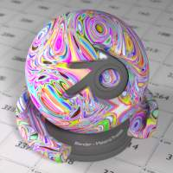
Magic texture: Depth 10, Distortion 2.0
Psychedelic color texture.
Depth
Number of iterations.
Vector input
Texture coordinate to sample texture at; defaults to Generated texture coordinates if the socket is left unconnected.
Distortion input
Amount of distortion.
Color output
Texture color output.
Fac output
Texture intensity output.

Checker Texture

Default Checker texture
Checkerboard texture.
Vector input
Texture coordinate to sample texture at; defaults to Generated texture coordinates if the socket is left unconnected.
Color1/2 input
Color of the checkers.
Scale input
Overall texture scale. The scale is a factor of the bounding box of the face divided by the scale. For example, a scale of 15 will result in 15 alternate patterns over the overall UV bounding box. Different patterns could be achieved using other nodes to give different input patterns to this socket. For example, using the Math Node.
Color output
Texture color output.
Fac output
Checker 1 mask (1 = Checker 1).

Brick Texture
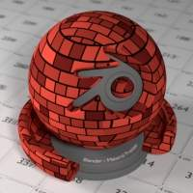
Brick texture: Colors changed, Squash 0.62, Squash Frequency 3.
Procedural texture producing Bricks.

Options
Offset
Determines the brick offset of the various rows.
Frequency
Determines the offset frequency. A value of 2 gives a even/uneven pattern of rows.
Squash
Amount of brick squashing.
Frequency
Brick squashing frequency.

Sockets
Color 1/2 and Mortar
Color of the bricks and mortar.
Scale
Overall texture scale.
Mortar Size
The Mortar size; 0 means no Mortar.
Bias
The color variation between Brick color 1 / 2. Values of -1 and 1 only use one of the two colors; values in between mix the colors.
Brick Width
The width of the bricks.
Row Height
The height of the brick rows.
Color output
Texture color output.
Fac output
Mortar mask (1 = mortar).

Point Density
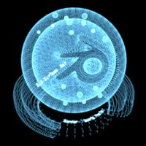
Domain object with Point Density texture using vertices from ball as points.
Used to add volumetric points for each particle or vertex of another object.

Options
Point Data
Where to get points from.
Particle System
Use each particle position from the specified particle system.
Object Vertices
Use each vertex position from the specified object.
Object
Which object’s vertices or particle system will be used.
Particle System
Particle positions from this system will be used.
Space
The coordinate system for mapping points.
World Space
Map each point exactly where the source particle/vertex is.
Object Space
Fit the points from the source particles/vertices inside the bounding box of the object with the point density texture. .. TODO As far as I can tell this is how it works, but should be checked with a developer.
Radius
Radius from the shaded sample to look for points within. .. TODO Same as tooltip, this does not make much sense to me.
Interpolation
Texel filtering type.
Closest
No interpolation, use nearest texel. Produces blocky looking points.
Linear
Interpolate linearly between texels, producing soft, round points.
Cubic
Use cubic falloff, producing very soft points. Useful when points are very densely packed.
Resolution
The dimensions of the texture holding the point data.
Color Source
Which attribute of the particle system is used to color the output.

Sockets
Vector
Texture coordinate to sample texture at; defaults to global position (Position output of Geometry node) if the socket is left unconnected.
Color output
Texture color output.
Density output
Density of volume.

More Nodes

Value
Input a scalar value.
Value
Value output.

RGB
Input an RGB color.
Color
RGB color output.

Geometry
Geometric information about the current shading point. All vector coordinates are in World Space. For volume shaders, only the position and incoming vector are available.
Position
Position of the shading point.
Normal
Shading normal at the surface (includes smooth normals and bump mapping).
Tangent
Tangent at the surface.
True Normal
Geometry or flat normal of the surface.
Incoming
Vector pointing towards the point the shading point is being viewed from.
Parametric
Parametric coordinates of the shading point on the surface.
Backfacing
1.0 if the face is being viewed from the backside, 0.0 for the frontside.

Wireframe
Node for a wireframe shader (Triangles only for now).
Pixel Size
Use screen pixel size instead of world units.
Size
Controls the thickness of the wireframe.
Fac output
1.0 if shading is executed on an edge, 0.0 otherwise.

Wavelength
A wavelength to rgb converter.
Wavelength
The color wavelength from 380 to 780 nanometers.
Color
RGB color output.

Blackbody
A blackbody temperature to RGB converter.
Temperature
The temperature in Kelvin.
Color
RGB color output.

Texture Coordinates
Commonly used texture coordinates, typically used as inputs for the Vector input for texture nodes.
Generated
Automatically-generated texture coordinates from the vertex positions of the mesh without deformation, keeping them sticking to the surface under animation. Range from 0.0 to 1. 0 over the bounding box of the undeformed mesh.
Normal
Object space normal, for texturing objects with the texture staying fixed on the object as it transformed.
UV
UV texture coordinates from the active render UV layer.
Object
Position coordinate in object space.
Camera
Position coordinate in camera space.
Window
Location of shading point on the screen, ranging from 0.0 to 1. 0 from the left to right side and bottom to top of the render.
Reflection
Vector in the direction of a sharp reflection, typically used for environment maps.

Bump
Generate a perturbed normal from a height texture, for bump mapping. The height value will be sampled at the shading point and two nearby points on the surface to determine the local direction of the normal.
Invert
Invert the bump mapping, to displace into the surface instead of out.
Strength Input
Strength of the bump mapping effect, interpolating between no bump mapping and full bump mapping.
Distance Input
Multiplier for the height value to control the overall distance for bump mapping.
Height Input
Scalar value giving the height offset from the surface at the shading point; this is where you plug in textures.

Vector Transform
Allows converting a Vector, Point or Normal between World <=> Camera <=> Object coordinate space.
Type
Specifies the input/output type: Vector, Point or Normal.
Convert From
Coordinate Space to convert from: World, Object or Camera.
Convert To
Coordinate Space to convert to: World, Object or Camera.
Vector Input
The input vector.
Vector Output
The transformed output vector.

Tangent
Generate a tangent direction for the Anisotropic BSDF.
Direction Type
The tangent direction can be derived from a cylindrical projection around the X, Y or Z axis (Radial), or from a manually created UV Map for full control.
Tangent Output
The tangent direction vector.

Normal Map
Generate a perturbed normal from an RGB normal map image. This is usually chained with an Image Texture node in the color input, to specify the normal map image. For tangent space normal maps, the UV coordinates for the image must match, and the image texture should be set to Non-Color mode to give correct results.
Space
The input RGB color can be in one of 3 spaces: Tangent, Object and World space. Tangent space normal maps are the most common, as they support object transformation and mesh deformations. Object space normal maps keep sticking to the surface under object transformations, while World normal maps do not.
UV Map
Name of the UV map to derive normal mapping tangents from. When chained with an Image Texture node, this UV map should be the same as the UV map used to map the texture.
Strength
Strength of the normal mapping effect.
Color Input
RGB color that encodes the normal in the specified space.
Normal Output
Normal that can be used as an input to BSDF nodes.

Object Info
Information about the object instance. This can be useful to give some variation to a single material assigned to multiple instances, either manually controlled through the object index, based on the object location, or randomized for each instance. For example a Noise texture can give random colors or a Color ramp can give a range of colors to be randomly picked from.
Note that this node only works for material shading nodes; it does nothing for lamp and world shading nodes.
Location
Location of the object in world space.
Object Index
Object pass index, same as in the Object Index pass.transformed.
Material Index
Material pass index, same as in the Material Index pass.
Random
Random number between 0 and 1 unique to a single object instance.

Particle Info
For objects instanced from a particle system, this node give access to the data of the particle that spawned the instance. This node currently only supports parent particles, info from child particles is not available.
Index
Index number of the particle (from 0 to number of particles).
Age
Age of the particle in frames.
Lifetime
Total lifespan of the particle in frames.
Location
Location of the particle.
Size
Size of the particle.
Velocity
Velocity of the particle.
Angular Velocity
Angular velocity of the particle.

Hair Info
This node gives access to strand information.
Is strand
Returns 1 when the shader is acting on a strand, otherwise 0.
Intersect
The point along the strand where the ray hits the strand (1 at the tip and 0 at the root).
Thickness
The thickness of the strand at the point where the ray hits the strand.
Tangent Normal
Tangent normal of the strand.

Attribute
Retrieve attribute attached to the object or mesh. Currently UV maps and vertex color layers can be retrieved this way by their names, with layers and attributes planned to be added. Also internal attributes like P (position), N (normal), Ng (geometric normal) may be accessed this way, although there are more convenient nodes for this.
Name
Name of the attribute.
Color output
RGB color interpolated from the attribute.
Vector output
XYZ vector interpolated from the attribute.
Fac output
Scalar value interpolated from the attribute.

Mapping
Transform a coordinate; typically used for modifying texture coordinates.
Location
Vector translation.
Rotation
Rotation of the vector along XYZ axes.
Scale
Scale of the vector.
Vector input
Vector to be transformed.
Vector output
Transformed vector.

Layer Weight
Output weights typically used for layering shaders with the Mix Shader node.
Blend input
Blend between the first and second shader.
Fresnel output
Dielectric fresnel weight, useful for example to layer diffuse and glossy shaders to create a plastic material. This is like the Fresnel node, except that the input of this node is in the often more-convenient 0.0 to 1.0 range.
Facing output
Weight that blends from the first to the second shader as the surface goes from facing the viewer to viewing it at a grazing angle.

Fresnel
Dielectric fresnel, computing how much light is reflected off a layer, where the rest will be refracted through the layer. The resulting weight can be used for layering shaders with the Mix Shader node. It is dependent on the angle between the surface normal and the viewing direction.
The most common use is to mix between two BSDFs using it as a blending factor in a mix shader node. For a simple glass material you would mix between a glossy refraction and glossy reflection. At grazing angles more light will be reflected than refracted as happens in reality.
For a two-layered material with a diffuse base and a glossy coating, you can use the same setup, mixing between a diffuse and glossy BSDF. By using the fresnel as the blending factor you’re specifying that any light which is refracted through the glossy coating layer would hit the diffuse base and be reflected off that.
IOR input
Index of refraction of the material being entered.
Fresnel output
Fresnel weight, indicating the probability with which light will reflect off the layer rather than passing through.

Light Path
Node to find out for which kind of incoming ray the shader is being executed; particularly useful for non-physically based tricks. More information about the meaning of each type is in the Light Paths documentation.
Is Camera Ray output
1.0 if shading is executed for a camera ray, 0.0 otherwise.
Is Shadow Ray output
1.0 if shading is executed for a shadow ray, 0.0 otherwise.
Is Diffuse Ray output
1.0 if shading is executed for a diffuse ray, 0.0 otherwise.
Is Glossy Ray output
1.0 if shading is executed for a glossy ray, 0.0 otherwise.
Is Singular Ray output
1.0 if shading is executed for a singular ray, 0.0 otherwise.
Is Reflection Ray output
1.0 if shading is executed for a reflection ray, 0.0 otherwise.
Is Transmission Ray output
1.0 if shading is executed for a transmission ray, 0.0 otherwise.
Ray Length output
Distance travelled by the light ray from the last bounce or camera.
Ray Depth output
Returns the current light bounce.
Transparent Depth output
Returns the number of transparent surfaces passed through.

Light Falloff
Manipulate how light intensity decreases over distance. In reality light will always fall off quadratically; however it can be useful to manipulate as a non-physically based lighting trick. Note that using Linear or Constant falloff may cause more light to be introduced with every global illumination bounce, making the resulting image extremely bright if many bounces are used.
Strength input
Light strength before applying falloff modification.
Smooth input
Smooth intensity of light near light sources. This can avoid harsh highlights, and reduce global illumination noise. 0.0 corresponds to no smoothing; higher values smooth more. The maximum light strength will be strength/smooth.
Quadratic output
Quadratic light falloff; this will leave strength unmodified if smooth is 0.0 and corresponds to reality.
Linear output
Linear light falloff, giving a slower decrease in intensity over distance.
Constant output
Constant light falloff, where the distance to the light has no influence on its intensity.

Nodes shared with the Compositor
Some nodes are common with Composite nodes, their documentation can be found at their relevant pages rather than repeated here.
- Brightness Contrast
- Separate RGB
- Combine RGB
- Separate HSV
- Combine HSV
- Gamma
- Hue Saturation Value
- Invert
- Math
- Mix RGB
- RGB Curves
- RGB to BW
- Vector Curve

